Name: Looi Kah Fung

Matric no: P-COM0049/22

Date: 10th Nov 2022

Course: Lab 4 CDS502 Principles & Practices of Data Science and Analytics

1.



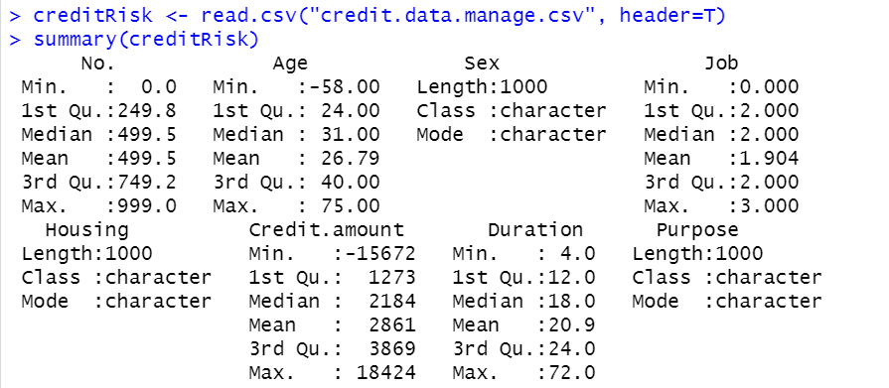

2.





3.

4.

* Delete the rows drop()
* Replacing the outliers with mean, median, mode ifelse(conditional x, replace_value, return to dataset) 🡨 preferable this approach, con is that it will increase imputation that would increase bias and variance of the dataset
* Replacing the outliers with max/min values

5.

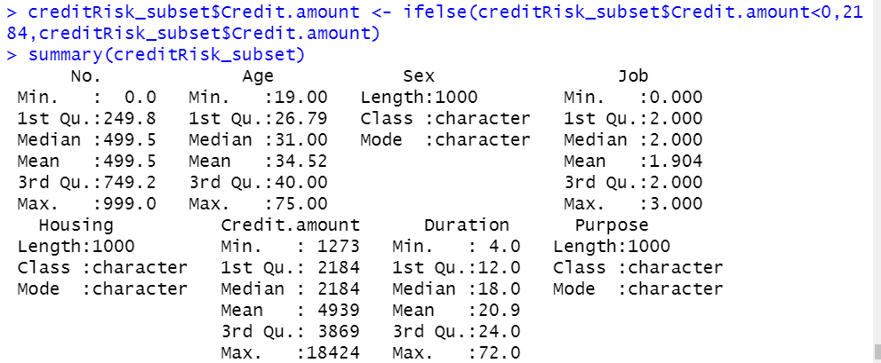

6.



